ASSIGNMENT 1.4
NAME : BERELLI PRIYANKA
HALL TICKET NO : 2303A52468
BATCH NO : 42

Task 1: AI-Generated Logic Without Modularization (Prime Number Check
Without Functions).
CODE :
Generate a Python program to check whether a number is prime.
Here is a simple Python program to check whether a number is prime:```python
def is_prime(n):
if n <= 1:
return False
for i in range(2, int(n**0.5) + 1):
if n % i == 0:
return False
return True
# Get user input
number = int(input("Enter a number: "))
if is_prime(number):
print(f"{number} is a prime number.")
else:
print(f"{number} is not a prime number.")
```This program defines a function `is_prime` that checks if a number `n` is prime. It first checks if `n` is less than or equal to 1, in which case it
returns `False`. Then it checks for factors from 2 up to the square root of `n`. If any factor divides `n` evenly, it returns `False`. If no factors are found, it returns `True`, indicating that `n` is prime. The program then prompts the user to enter a number and uses the function to check if it's prime, printing the result accordingly.
<!DOCTYPE html>
<html lang="en">
<head>
<meta charset="UTF-8">
<meta name="viewport" content="width=device-width, initial-scale=1.0">
<title>Modal Popup Notification</title>
<style>
/* Basic styling for the modal */
.modal {
display: none; /* Hidden by default */
position: fixed; /* Stay in place */
z-index: 1; /* Sit on top */
left: 0;
top: 0;
width: 100%; /* Full width */
height: 100%; /* Full height */
overflow: auto; /* Enable scroll if needed */
background-color: rgb(0,0,0); /* Fallback color */
background-color: rgba(0,0,0,0.4); /* Black w/ opacity */
}
.modal-content {
background-color: #fefefe;
margin: 15% auto; /* 15% from the top and centered */
padding: 20px;
border: 1px solid #888;
width: 80%; /* Could be more or less, depending on screen size */
}
.close {
color: #aaa;
float: right;
font-size: 28px;
font-weight: bold;
}
.close:hover,
.close:focus {
color: black;
text-decoration: none;
cursor: pointer;
}
</style>
</head>
<body>
<!-- Trigger/Open The Modal -->
<button id="myBtn">Open Modal</button>

<!-- The Modal -->
<div id="myModal" class="modal">
<!-- Modal content -->
<div class="modal-content">
<span class="close">&times;</span>
<p>This is a modal popup notification!</p>
</div>
</div>

<script>
// Get the modal element
const modal = document.getElementById('myModal');
// Get the button that opens the modal
const btn = document.getElementById('myBtn');
// Get the <span> element that closes the modal
const span = document.getElementsByClassName('close')[0];

// When the user clicks the button, open the modal
btn.onclick = function() {
modal.style.display = 'block';
}

// When the user clicks on <span> (x), close the modal
span.onclick = function() {
modal.style.display = 'none';
}

// When the user clicks anywhere outside of the modal, close it
window.onclick = function(event) {
if (event.target == modal) {
modal.style.display = 'none';
}
}
</script>
</body>
</html>

OUTPUT :
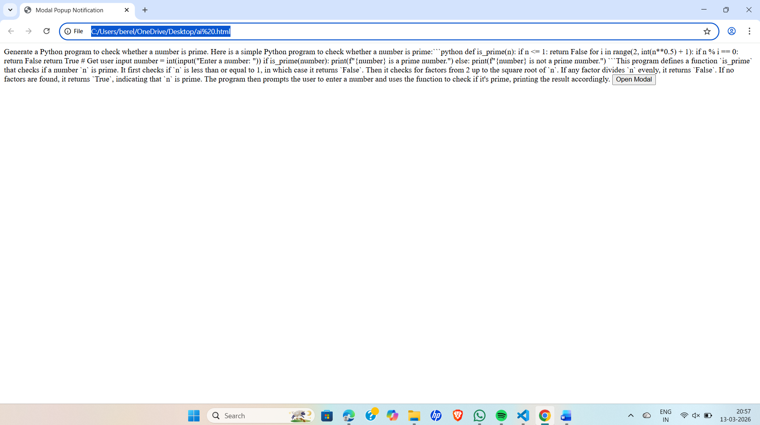
LINK : file:///C:/Users/berel/OneDrive/Desktop/ai%20.html

EXAPLAINATION : This task is to create a Python program that checks if a number is prime. The program takes user input and uses a loop to check divisibility. The logic is written directly in the main code without using functions. It then prints “Prime number” or “Not a prime number.”
Task 2: Efficiency & Logic Optimization (Cleanup)
Prompt : Optimize this Python prime number checking code.
CODE:
Optimize this Python prime number checking code.
Here is an optimized version of the Python program to check whether a number is prime:```python
def is_prime(n):
if n <= 1:
return False
if n <= 3:
return True
if n % 2 == 0 or n % 3 == 0:
return False
i = 5
while i * i <= n:
if n % i == 0 or n % (i + 2) == 0:
return False
i += 6
return True

# Get user input
number = int(input("Enter a number: "))
if is_prime(number):
print(f"{number} is a prime number.")
else:
print(f"{number} is not a prime number.")
```This optimized version of the `is_prime` function first checks for numbers less than or equal to 3, which are prime. It then eliminates even numbers greater than 2 and numbers divisible by 3. Finally, it uses a loop to check for factors starting from 5, checking only numbers of the form 6k ± 1 (i.e., 5, 7, 11, 13, etc.) up to the square root of `n`. This approach significantly reduces the number of iterations needed to determine if a number is prime, especially for larger numbers. The rest of the program remains unchanged, prompting the user for input and printing whether the number is prime or not.
<!DOCTYPE html>
<html lang="en">
</html>
<head>
<meta charset="UTF-8">
<meta name="viewport" content="width=device-width, initial-scale=1.0">
<title>Modal Popup Notification</title>
<style>
/* Basic styling for the modal */
.modal {
display: none; /* Hidden by default */
position: fixed; /* Stay in place */
z-index: 1; /* Sit on top */
left: 0;
top: 0;
width: 100%; /* Full width */
height: 100%; /* Full height */
overflow: auto; /* Enable scroll if needed */
background-color: rgb(0,0,0); /* Fallback color */
background-color: rgba(0,0,0,0.4); /* Black w/ opacity */
}
.modal-content {
background-color: #fefefe;
margin: 15% auto; /* 15% from the top and centered */
padding: 20px;
border: 1px solid #888;
width: 80%; /* Could be more or less, depending on screen size */
}
.close {
color: #aaa;
float: right;
font-size: 28px;
font-weight: bold;
}
.close:hover,
.close:focus {
color: black;
text-decoration: none;
cursor: pointer;
}
</style>
</head>
<body>

OUTPUT :
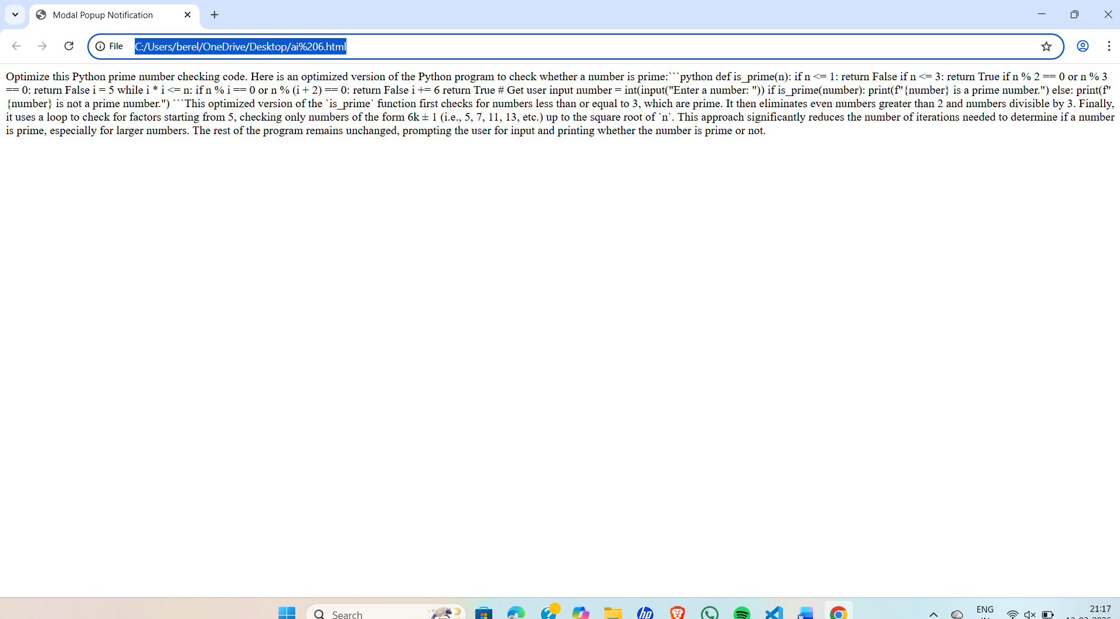
LINK : file:///C:/Users/berel/OneDrive/Desktop/ai%206.html

EXPLAINATION : In this task, the prime number program from Task 1 is reviewed and improved. The code is optimized by reducing unnecessary loop iterations, using early termination, and making the code more readable and efficient. These improvements help the program run faster for larger numbers and reduce time complexity.
Task 3: Modular Design Using AI Assistance (Prime Number Check Using Functions)
Prompt : Generate a Python program to check whether a number is prime using a user-defined function.
CODE :
Generate a Python program to check whether a number is prime using a user-defined function.
Here is a simple Python program to check whether a number is prime using a user-defined function:```python
def is_prime(n):
if n <= 1:
return False
for i in range(2, int(n**0.5) + 1):
if n % i == 0:
return False
return True
# Get user input
number = int(input("Enter a number: "))
if is_prime(number):
print(f"{number} is a prime number.")
else:
print(f"{number} is not a prime number.")
```This program defines a function `is_prime` that checks if a number `n` is prime. It first checks if `n` is less than or equal to 1, in which case it returns `False`. Then it checks for factors from 2 up to the square root of `n`. If any factor divides `n` evenly, it returns `False`. If no factors are found, it returns `True`, indicating that `n` is prime. The program then prompts the user to enter a number and uses the function to check if it's prime, printing the result accordingly.
<!DOCTYPE html>
<html lang="en">

<head>
<meta charset="UTF-8">
<meta name="viewport" content="width=device-width, initial-scale=1.0">
<title>Modal Popup Notification</title>
<style>
/* Basic styling for the modal */
.modal {
display: none; /* Hidden by default */
position: fixed; /* Stay in place */
z-index: 1; /* Sit on top */
left: 0;
top: 0;
width: 100%; /* Full width */
height: 100%; /* Full height */
overflow: auto; /* Enable scroll if needed */
background-color: rgb(0,0,0); /* Fallback color */
background-color: rgba(0,0,0,0.4); /* Black w/ opacity */
}
.modal-content {
background-color: #fefefe;
margin: 15% auto; /* 15% from the top and centered */
padding: 20px;
border: 1px solid #888;
width: 80%; /* Could be more or less, depending on screen size */
}
.close {
color: #aaa;
float: right;
font-size: 28px;
font-weight: bold;
}
.close:hover,
.close:focus {
color: black;
text-decoration: none;
cursor: pointer;
}
</style>
</head>
<body>
<!-- Trigger/Open The Modal -->
<button id="myBtn">Open Modal</button>

<!-- The Modal -->
<div id="myModal" class="modal">
<!-- Modal content -->
<div class="modal-content">
<span class="close">&times;</span>
<p>This is a modal popup notification!</p>
</div>
</div>

<script>
// Get the modal element
const modal = document.getElementById('myModal');
// Get the button that opens the modal
const btn = document.getElementById('myBtn');
// Get the <span> element that closes the modal
const span = document.getElementsByClassName('close')[0];

// When the user clicks the button, open the modal
btn.onclick = function() {
modal.style.display = 'block';
}

// When the user clicks on <span> (x), close the modal
span.onclick = function() {
modal.style.display = 'none';
}

// When the user clicks anywhere outside of the modal, close it
window.onclick = function(event) {
if (event.target == modal) {
modal.style.display = 'none';
}
}
</script>
</body>
</html>
Here is an optimized version of the `is_prime` function that reduces the number of iterations needed to check for primality:
```python
def is_prime(n):
if n <= 1:
return False
if n <= 3:
return True
if n % 2 == 0 or n % 3 == 0:
return False
i = 5
while i * i <= n:
if n % i == 0 or n % (i + 2) == 0:
return False
i += 6
return True

# Get user input
number = int(input("Enter a number: "))
if is_prime(number):
print(f"{number} is a prime number.")
else:
print(f"{number} is not a prime number.")
```This optimized version of the `is_prime` function first checks for numbers less than or equal to 3, which are prime. It then eliminates even numbers greater than 2 and numbers divisible by 3. Finally, it uses a loop to check for factors starting from 5, checking only numbers of the form 6k ± 1 (i.e., 5, 7, 11, 13, etc.) up to the square root of `n`. This approach significantly reduces the number of iterations needed to determine if a number is prime, especially for larger numbers. The rest of the program remains unchanged, prompting the user for input and printing whether the number is prime or not.

OUTPUT :
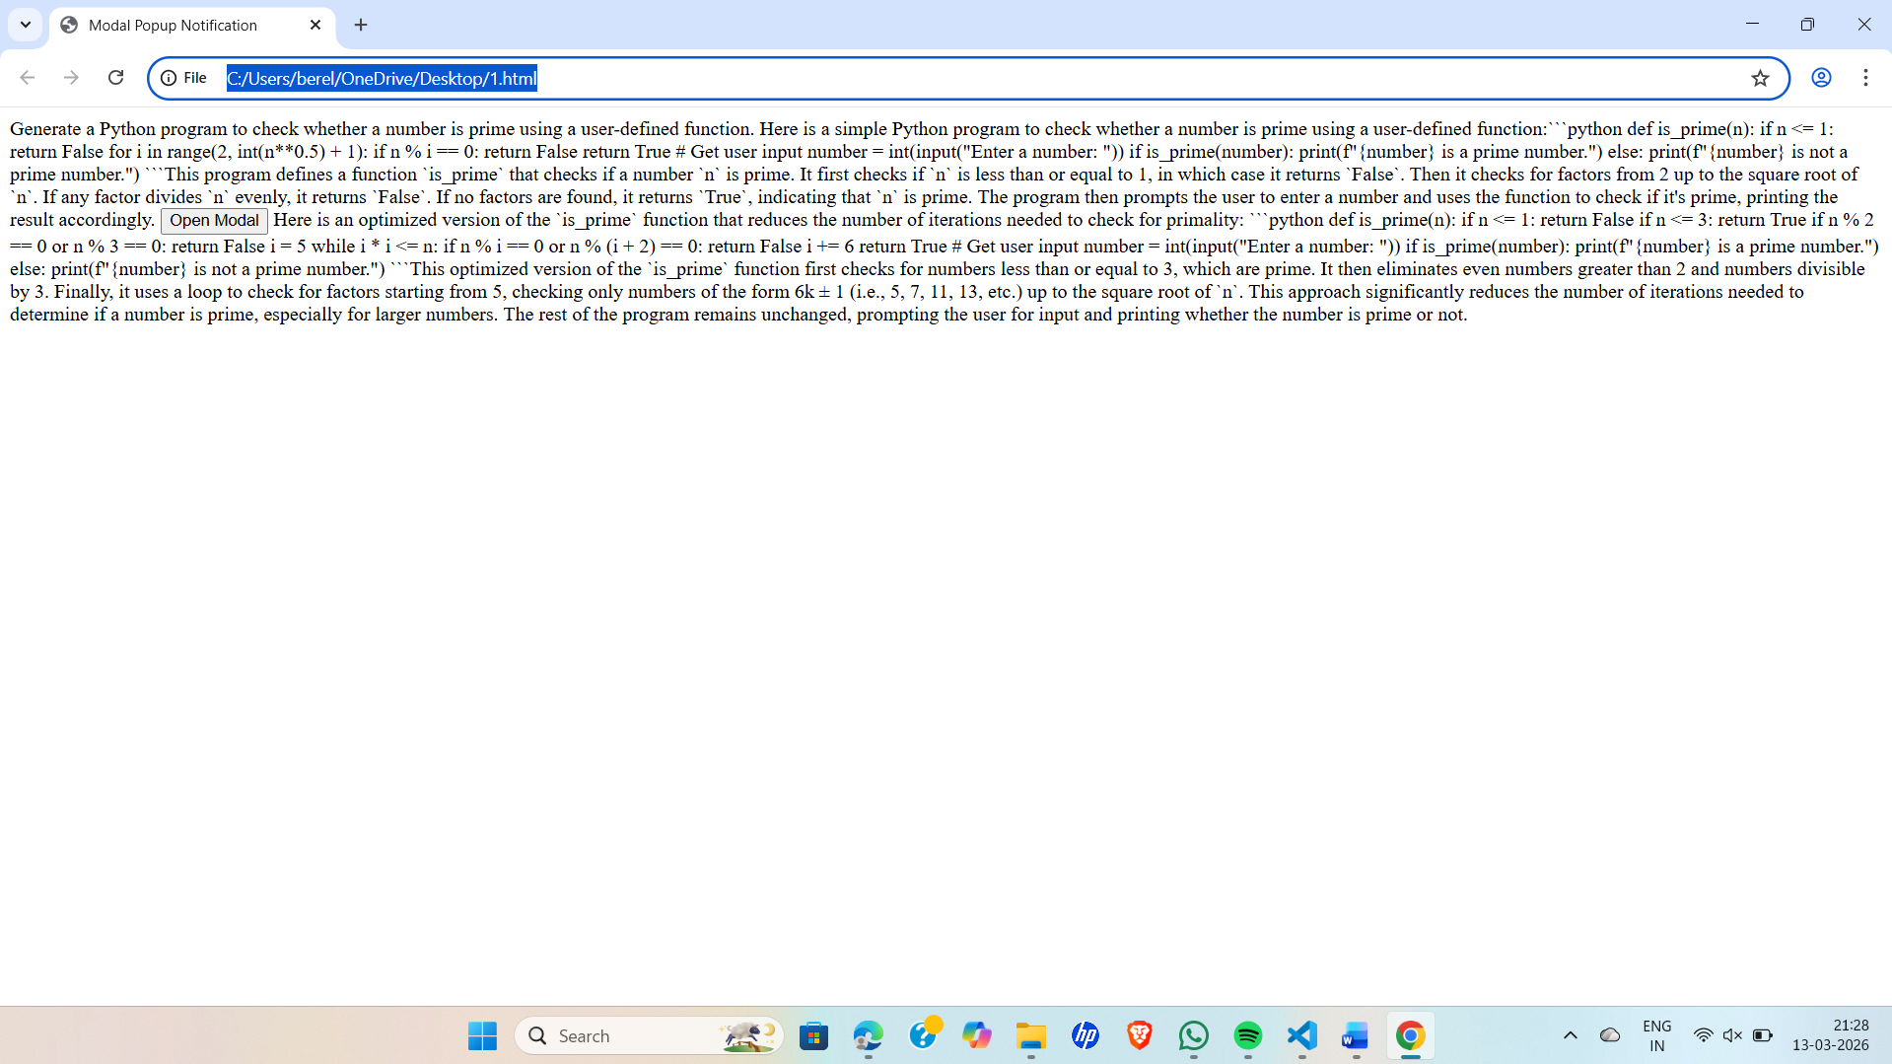

LINK : file:///C:/Users/berel/OneDrive/Desktop/1.html
EXPLAINATION : In this task, the prime number logic is written using a user-defined function. The function checks if a number is prime and returns True or False. The main program calls this function and prints the result. This modular design makes the code reusable, organized, and easier to maintain.
Task 4: Comparative Analysis –With vs Without Functions.
Prompt : Compare two Python programs for prime number checking: one without functions and one using a user-defined function.
CODE:
Compare two Python programs for prime number checking: one without functions and one using a user-defined function.
Here is a Python program to check whether a number is prime without using a function:```python
number = int(input("Enter a number: "))
if number <= 1:
print(f"{number} is not a prime number.")
else:
is_prime = True
for i in range(2, int(number**0.5) + 1):
if number % i == 0:
is_prime = False
break
if is_prime:
print(f"{number} is a prime number.")
else:
print(f"{number} is not a prime number.")
```This program prompts the user to enter a number and checks if it's prime by iterating through possible factors. It uses a boolean variable `is_prime` to keep track of whether the number is prime or not. If any factor divides the number evenly, it sets `is_prime` to `False` and breaks out of the loop. Finally, it prints whether the number is prime or not based on the value of `is_prime`.
Here is a Python program to check whether a number is prime using a user-defined function:```python
def is_prime(n):
if n <= 1:
return False
for i in range(2, int(n**0.5) + 1):
if n % i == 0:
return False
return True
# Get user input
number = int(input("Enter a number: "))
if is_prime(number):
print(f"{number} is a prime number.")
else:
print(f"{number} is not a prime number.")
```This program defines a function `is_prime` that checks if a number `n` is prime. It first checks if `n` is less than or equal to 1, in which case it returns `False`. Then it checks for factors from 2 up to the square root of `n`. If any factor divides `n` evenly, it returns `False`. If no factors are found, it returns `True`, indicating that `n` is prime. The program then prompts the user to enter a number and uses the function to check if it's prime, printing the result accordingly.
<!DOCTYPE html>
<html lang="en">
</html>
<head>
<meta charset="UTF-8">
<meta name="viewport" content="width=device-width, initial-scale=1.0">
<title>Modal Popup Notification</title>
<style>
/* Basic styling for the modal */
.modal {
display: none; /* Hidden by default */
position: fixed; /* Stay in place */
z-index: 1; /* Sit on top */
left: 0;
top: 0;
width: 100%; /* Full width */
height: 100%; /* Full height */
overflow: auto; /* Enable scroll if needed */
background-color: rgb(0,0,0); /* Fallback color */
background-color: rgba(0,0,0,0.4); /* Black w/ opacity */
}
.modal-content {
background-color: #fefefe;
margin: 15% auto; /* 15% from the top and centered */
padding: 20px;
border: 1px solid #888;
width: 80%; /* Could be more or less, depending on screen size */
}
.close {
color: #aaa;
float: right;
font-size: 28px;
font-weight: bold;
}
.close:hover,
.close:focus {
color: black;
text-decoration: none;
cursor: pointer;
}
</style>
</head>
<body>
<!-- Trigger/Open The Modal -->
<button id="myBtn">Open Modal</button>

<!-- The Modal -->
<div id="myModal" class="modal">
<!-- Modal content -->
<div class="modal-content">
<span class="close">&times;</span>
<p>This is a modal popup notification!</p>
</div>
</div>

<script>
// Get the modal element
const modal = document.getElementById('myModal');
// Get the button that opens the modal
const btn = document.getElementById('myBtn');
// Get the <span> element that closes the modal
const span = document.getElementsByClassName('close')[0];

// When the user clicks the button, open the modal
btn.onclick = function() {
modal.style.display = 'block';
}

// When the user clicks on <span> (x), close the modal
span.onclick = function() {
modal.style.display = 'none';
}

// When the user clicks anywhere outside of the modal, close it
window.onclick = function(event) {
if (event.target == modal) {
modal.style.display = 'none';
}
}
</script>
</body>
</html>
Here is an optimized version of the `is_prime` function that reduces the number of iterations needed to check for primality:```python
def is_prime(n):
if n <= 1:
return False
if n <= 3:
return True
if n % 2 == 0 or n % 3 == 0:
return False
i = 5
while i * i <= n:
if n % i == 0 or n % (i + 2) == 0:
return False
i += 6
return True

# Get user input
number = int(input("Enter a number: "))
if is_prime(number):
print(f"{number} is a prime number.")
else:
print(f"{number} is not a prime number.")
```This optimized version of the `is_prime` function first checks for numbers less than or equal to 3, which are prime. It then eliminates even numbers greater than 2 and numbers divisible by 3. Finally, it uses a loop to check for factors starting from 5, checking only numbers of the form 6k ± 1 (i.e., 5, 7, 11, 13, etc.) up to the square root of `n`. This approach significantly reduces the number of iterations needed to determine if a number is prime, especially for larger numbers. The rest of the program remains unchanged, prompting the user for input and printing whether the number is prime or not.

OUTPUT :
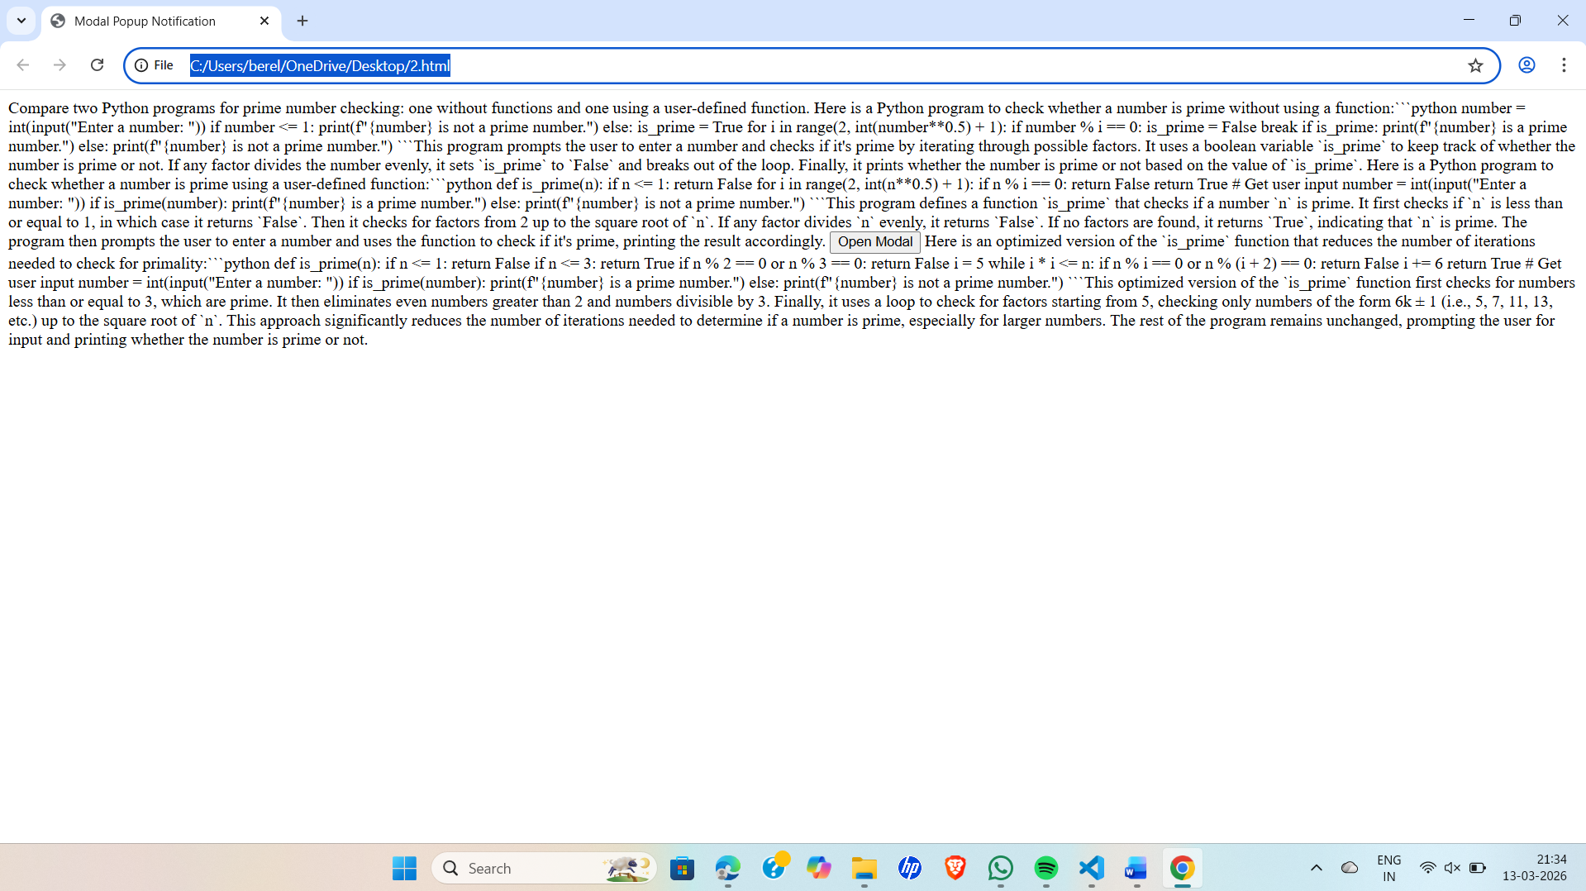
LINK : file:///C:/Users/berel/OneDrive/Desktop/2.html
EXPLAINATION : In this task, the two programs are compared: one written without functions and the other using functions. The comparison focuses on code clarity, reusability, ease of debugging, and suitability for large applications. This helps understand why modular code (using functions) is better for organized and scalable programs.
Task 5: AI-Generated Iterative vs Recursive Fibonacci Approaches (Different Algorithmic Approaches to Prime Checking)
Prompt : Generate two Python implementations for checking prime numbers:
CODE :
Generate two Python implementations for checking prime numbers:
1. A simple implementation without using functions.
2. An optimized implementation using a user-defined function.
Here is a simple Python program to check whether a number is prime without using a function:```pythonnumber = int(input("Enter a number: "))
if number <= 1:
print(f"{number} is not a prime number.")
else:
is_prime = True
for i in range(2, int(number**0.5) + 1):
if number % i == 0:
is_prime = False
break
if is_prime:
print(f"{number} is a prime number.")
else:
print(f"{number} is not a prime number.")
```This program prompts the user to enter a number and checks if it is prime by iterating from 2 up to the square root of the number. If any divisor is found, it sets `is_prime` to `False` and breaks the loop. Finally, it prints whether the number is prime or not based on the value of `is_prime`.
Here is an optimized version of the Python program to check whether a number is prime using a user
-defined function:```python
def is_prime(n):
if n <= 1:
return False
if n <= 3:
return True
if n % 2 == 0 or n % 3 == 0:
return False
i = 5
while i * i <= n:
if n % i == 0 or n % (i + 2) == 0:
return False
i += 6
return True
# Get user input
number = int(input("Enter a number: "))
if is_prime(number):
print(f"{number} is a prime number.")
else:
print(f"{number} is not a prime number.")
```This optimized version of the `is_prime` function first checks for numbers less than or equal to 3, which are prime. It then eliminates even numbers greater than 2 and numbers divisible by 3. Finally, it uses a loop to check for factors starting from 5, checking only numbers of the form 6k ± 1 (i.e., 5, 7, 11, 13, etc.) up to the square root of `n`. This approach significantly reduces the number of iterations needed to determine if a number is prime, especially for larger numbers. The rest of the program remains unchanged, prompting the user for input and printing whether the number is prime or not

OUTPUT :
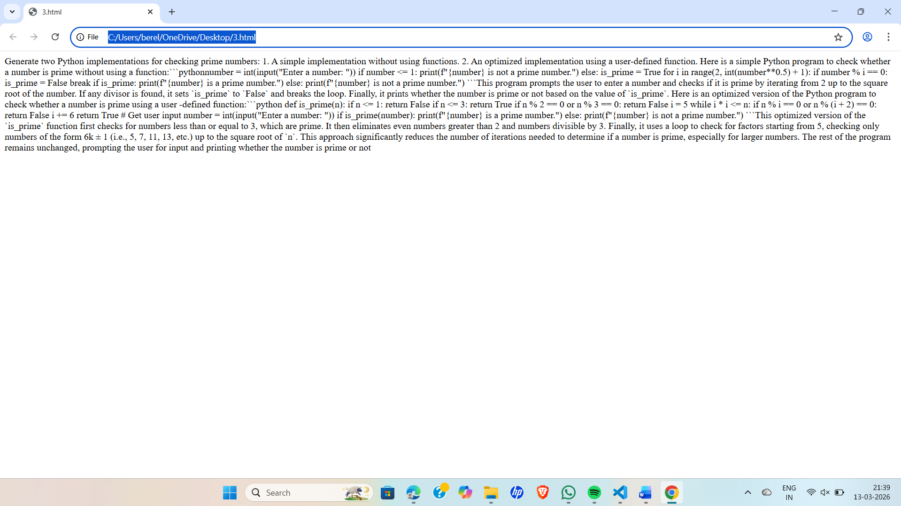
LINK : file:///C:/Users/berel/OneDrive/Desktop/3.html
EXPLAINATION : In this task, two different prime number checking approaches are generated using AI: a basic divisibility method and an optimized method that checks up to √n. The two implementations are compared based on execution flow, time complexity, and performance for large inputs to understand which approach is more efficient.

